**ASSIGNMENT COVER SHEET**

**Subject: 32027 Multimedia Systems Design**

**Lecturer/Supervisor: Dr Andrew Johnston & Dr Donna Hewitt**

**Assignment task 1: Concept, design, media and requirements doc. for multimedia project**

**Group name: Unidentified Frequency**

**Student ids: Jowell Tsai, 11605526**

**Aman Sharma, 11946860**

**Karthikeyan Subramanian, 11502349**

**Lionel Mischler, 11623129**

# Multimedia project: Starphonie

## Executive Summary

Zodiac star signs and star data can be hard to remember without astronomical background knowledge. Unidentified Frequency suggest a playful approach with our senses: touch, see and hear. The purpose of this multimedia project is an educational to discover the Zodiac star signs and stars and an artistic, to create visual shapes, lines and melodies through the use of abstract star data. The project influences are mainly from traditional Zodiac star signs and scientific research around stars and sounds. This project focused on users such as high school students, university students and adults who are interested in exploring or gaining astronomical information on stars and Zodiac constellations. Four scenarios have been identified: Learn the star signs, get more information about stars, compose melodies and create visual figures.

Starphonie provides information about stars by selecting a star and stars can also be connected to play different music or can be connected based on Zodiac signs to play music. User interaction consists of set of workspace each containing functionality relevant to the task. Starphonie is available on various devices such as computers, tablets and even an Xbox 360, that allows to user to interact in different ways: mouse, finger and even the body. The visual is created to enhance the whole experience of the app. The direction should look real and aesthetic. Although concept came with the approach of educational purpose, but the look of it is more abstract which is leaning toward an interactive art form. The sound strategy is defined by spacey, ambient background music in combination with unique piano notes triggered through the interaction with the stars. The user can tap or click on multiple stars to create a harmonic melody.

## Concept

Our starry sky can be observed every night and some people even recognize the Zodiac star signs that connect these stars together. However, most people don’t know them and learning from a book or an image can be quite difficult and sterile. Stars are identified with romantic, feelings and emotions and Unidentified Frequency (UF) believes that the Zodiac star signs should be explored with our senses in a playful way.

UF came with the idea to create an educational, abstract, interactive sonification and visualization of Zodiac star signs and stars. The user will be provided with an abstract starry sky on the screen. The stars are characterized through its visual size, brightness and colour. The background music elements transcend the feeling of space. The element of music is defined by Leung & Ward (2008) as an ‘emotional truth’ (Leung & Ward 2008, p. 85) that will make the interactive user feel physically in space.

Starphonie has two purposes: an educational and artistic purpose. Firstly, the stars and Zodiac star signs can be discovered and learned interactively. Starphonie is accompanied by sound and graphical effects that are based on the stars distance to earth and its size. Star information such as name, distance and size are written as well, to complete the educational purpose. The Zodiac star signs can be redrawn through connecting the stars with lines, that feedbacks a melody that can be edutaining, entertaining but also educational, because the Zodiac stars can be easier remembered with multiple senses.

Secondly the artistic purpose: Starphonie can be used to create shapes through connecting stars together, similar to Zodiac star signs. Moreover, it gives the Starphonie user the opportunity to create melodies, in a playful approach.

Unidentified Frequency team’s primary objective is to provide an educational approach to discover our starry sky and the Zodiac star signs for children and adults.

The second objective is an artistic one, to create melodies based on abstract scientific data of stars.

Main motivation for our project is to understand and explore interesting astronomical information about Zodiac signs and stars as well as the artistic opportunities that can be created with them. One of the interesting information we can understand is in regards to 12 Zodiac constellations that we all have some idea with the form of astrology. Constellations are patterns made by stars and there are 88 official set of constellation discovered. (International Astronomical Union n.d.)

Astronomical data analysis can be complicated and not easy understandable without astronomical metric knowledge of for instance star class and absolute magnitude. A table such as Powell’s (2006) List of Nearest Stars, can feel too technical and scientific. The major advantage is that Starphonie creates a bridge between scientific data and emotions in a visual and aural symbiosis. The discovery of these beautiful stars will be through our senses: touch, see and hear.

Starphonie will be available as an Android app, iPad app, Computer app & Xbox 360 application. Starphonie is defined as fun, minimalistic, space feeling, astronomic, simple, creative, spiritual, artistic and interesting.

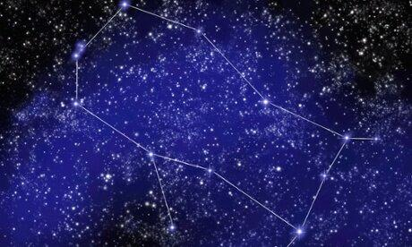Multiple sources influenced us to design and create this idea.

The concept is inspired from the Zodiac signs that are drawn by astronomers to study star constellations. UF team uses this idea and adds an additional purpose that the user can drag lines and connect the stars freely. Each star would have signifying sounds when connected.

The video Determining Star Size From Star Sounds (2014) proposes a new method to analyze a star’s size through sounds. The sound is caught through variations in brightness of the star, namely sunspots and the star spinning (ibid). The sound is accompanied by the hiss from gas circulation on the star’s surface, creating flickering light (ibid). Consequently scientists turn ‘the light into sound’ (Determining Star Size From Star Sounds 2014). During the video, the frequency of the tone is notable, whereas small dwarfs as the sun have a deep sound and sub giants or red giants have a higher tone frequency. This animated Unidentified Frequency to use this scientific finding and translate it into human musical notation and tones (piano).

The list of brightest stars visible to human eye (Wikipedia Inc. 2014), provided an important source to find out, which scientific data are known from these stars and could be used for Starphonie. The list includes 93 stars including the sun whereas one of the findings is that variable stars brightness can change over days, months or years and the list could change as well. Some of these stars are named as standard stars and their brightness stays unchanged.

The sound concept is inspired by the different piano notes, which creates a soothing melody. These melodies are mainly piano noted played in minor scale to create a ambient and relaxing sort of sounds. The melodies were mainly influenced by Deadmau5 (2014) new album “While 1<2”. The piano chords are warm and swelling with sound with uplifting piano interlude.

# Design

Note: The interaction is defined as tapping using a tablet (iPad or Android tablet). However, the application can be interacted as well with a mouse click in a computer (mac or windows) or with the X-Box, using the built-in ‘Hover to select’ (Microsoft Inc. 2014, para. 3) kinect gesture. (Microsoft Inc. 2014)

Scene 1: Starphonie start screen



**Visual**

Starphonie starts with the starry night landscape scene. Unidentified Frequency (UF) logo fades in. Once the logo has been fully appeared, it whirls horizontally in three dimensions.

**Interaction**

* Player taps the scene, then the logo fades out.

**Sound**

* The background music starts playing which is characterized as ambient and space.
* When the logo fades in the feedback sound effect appears. The same happens for the logo fade out.

# Scene 2: Stars & Star signs

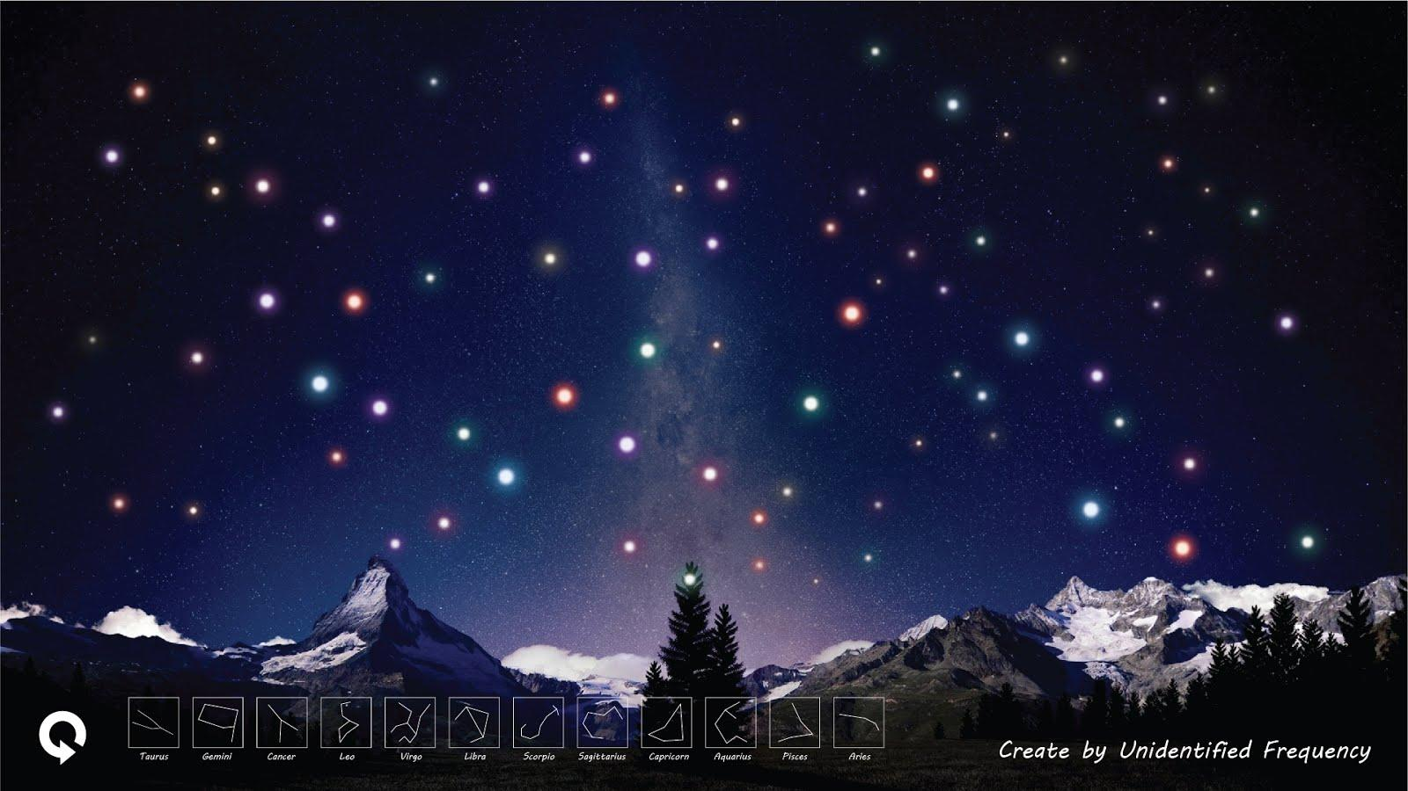

**Visual**

The stars fade in. Totally 7 different colour gems spread in the sky - Violet, Indigo, Blue, Green, Yellow, Orange and Red. These chosen colors are based on the Chakra color to highlight the spiritual touch from Starphonie (Mindbodygreen 2009). Sizes are different that would depend on the distance to the earth and the size of the star itself. All the stars continuously glow (animated). 12 Zodiac signs also appear at the bottom as thumbnails and the refresh button on the bottom left.

**Interaction**

The player can start interacting with the stars and has two possibilities:

* The user can tap on the star, the star gets brighter.
* When the player taps and holds on that star, the brightness continuously brightens up and the sound of the selected star is played continuously as long as the player didn’t release the star.

**Sound**

* The background sound continues to play as defined in scene 1.
* The sound of the selected star is determined by the size of the star. A large star defines a higher tone than a small star. In addition, the star’s sound reverb is defined by the star’s distance to earth. Than further away from planet earth, than more reverb.

# Scene 3: Finding Star Information

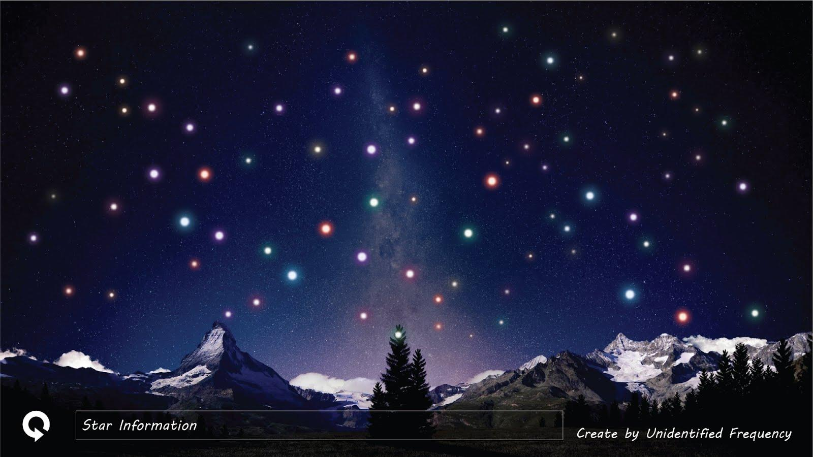

**Visual**

Selecting a single star gives “Star Name”, “Star size” and “Star Distance from Earth” inside the “Star Information” rectangular box. In this case, the Zodiac star signs as shown in Scene 2 are hidden.

**Interaction**

* A single star can be tapped to display star details.

**Sound**

* The background sound continues to play as defined in scene 1.
* The sound of a selected star is defined in scene 2.

# Scene 4: Create own star sign

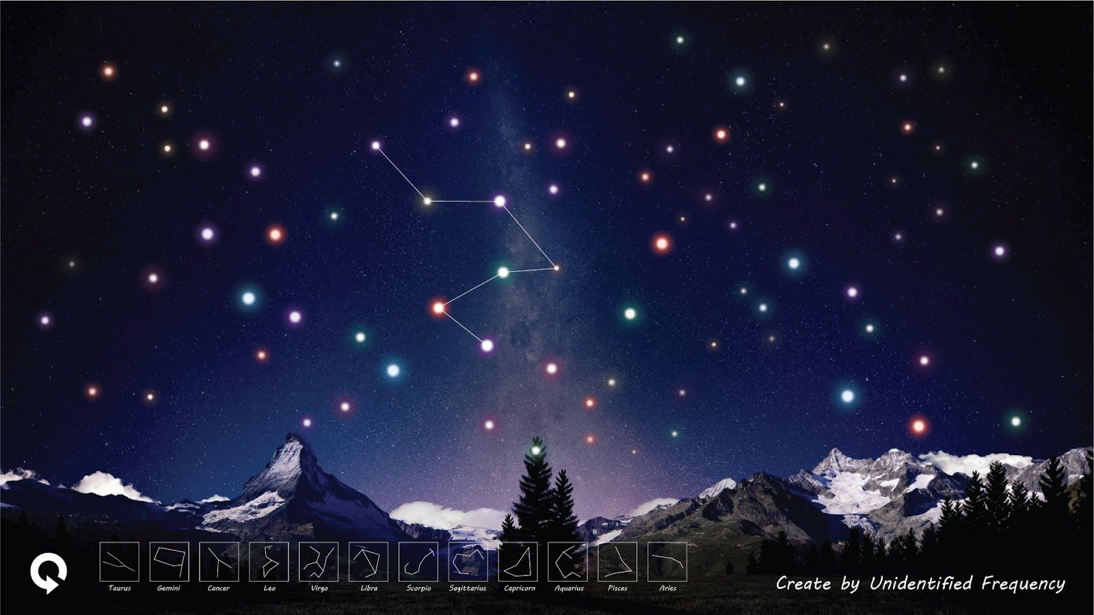

**Visual**

The connected stars are shown connected by a visible line.

**Interaction**

* To connect two stars, hold on one star and drag it to another star, then release.
* To add more stars, hold again and drag it to further stars, then release.
* The refresh button on the bottom left can be pressed to remove the lines and the looping melody.

**Sound**

* The background sound continues to play as defined in scene 1.
* When connecting stars, the star sounds from the connected stars appear, sequentially.
* The looping melody after connection the stars is defined in scene 5.

# Scene 5: Creating own star sign melody

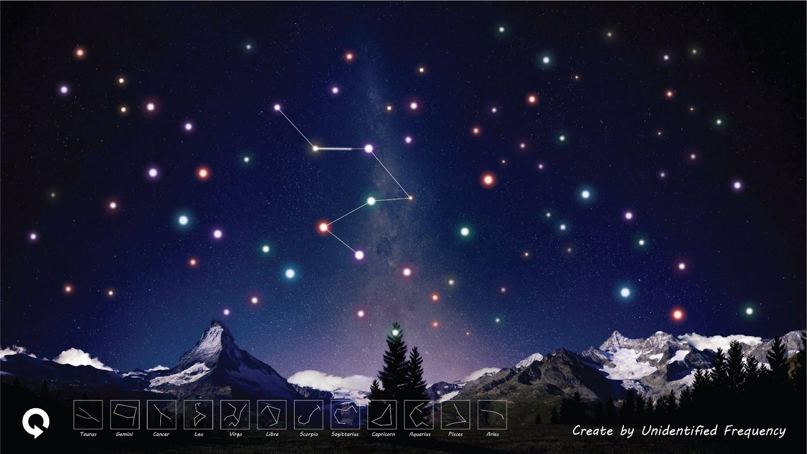

**Visual:**

The thicker glowing line (representing the sound) transits along the visible line that connect the stars. At this point, the player can ‘see’ the sound to play from one star to another.

**Interaction:**

* The looping melody can be turned off when clicking on the refresh button.
* The looping melody appears as soon as the user releases the finger from the screen.

**Sound:**

* The background sound continues to play as defined in scene 1.
* The sound of a selected star is defined in scene 2.
* Looping melody: As soon as two stars are connected and the finger released, each single star sound is played in a loop sequence, starting with the first star that was tapped, than with the second etc. The length from the star note played depends on the distance between two stars. Than further away the two stars are visually located on the map, than longer plays the tone.

# Scene 6: Selecting Zodiac star sign

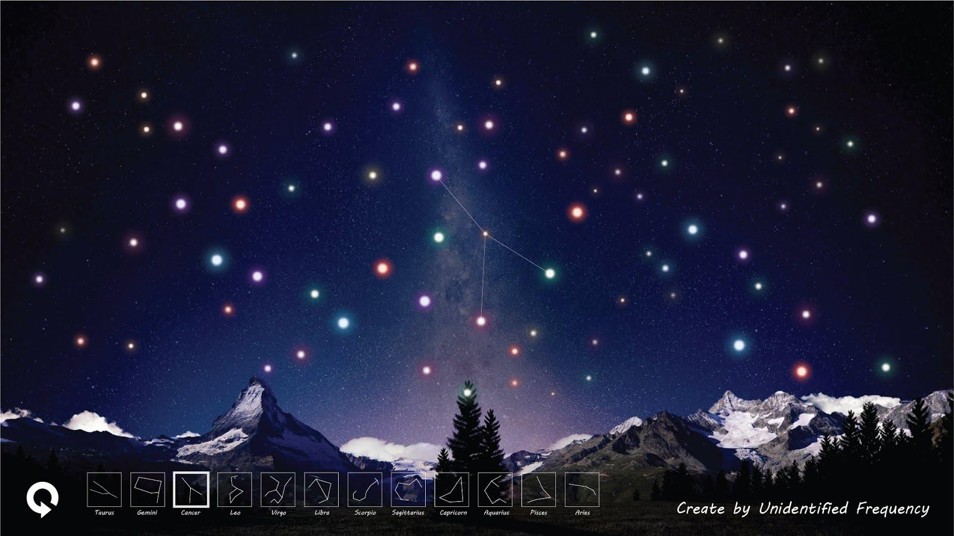

**Visual:**

One Zodiac thumbnail sign has been selected on the bottom and is highlighted by a thick square. The Zodiac sign is shown by a very thin line, as if it is a guideline for the player to drag on the track.

**Interaction:**

* Drag the line along the guideline to compose the Zodiac sign melody.

**Sound:**

* The background sound continues to play as defined in scene 1.

# Scene 7: Drawing multiple Zodiac star signs

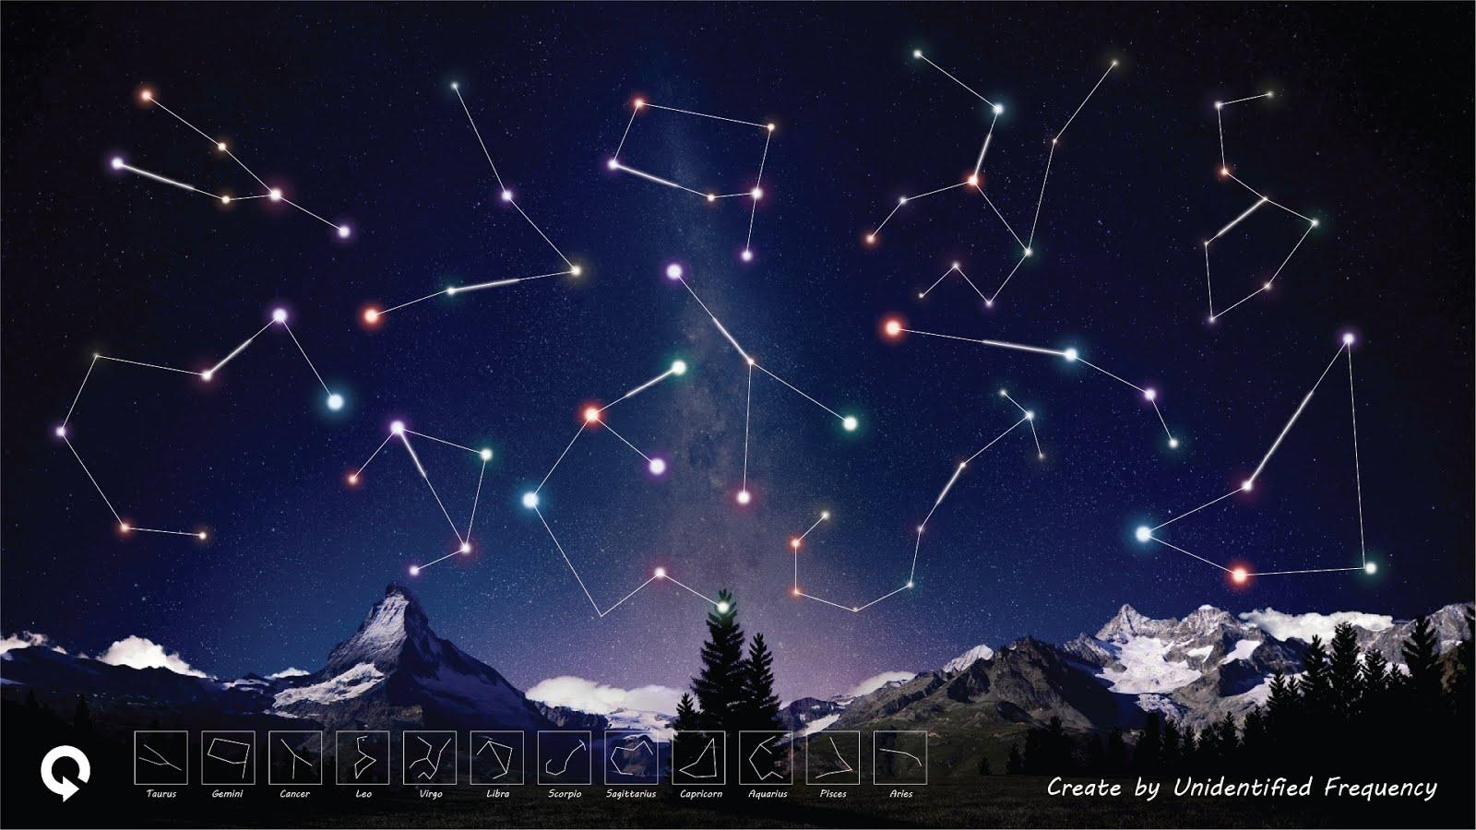

**Visual:**

The other lines are connected in different places to form different star signs. The thicker glowing lines are moving within the star signs at the same time.

**Interaction:**

* After the star sign was created, the player can form another star sign in the same scene by holding and dragging the line as described in scene 4.
* Press refresh button to go back to scene 2 - Restart.

**Sound:**

* The background sound continues to play as defined in scene 1.
* All the star signs sound would be played, but maybe in different timing, depending when they were released.
* The looping melody of star signs is defined as in scene 5.

## 

## Scenarios 1 - Wants to know about the star sign cancer

Scenario 1 by Lionel Mischler

**Primary persona: *Nicole Page***

|  |  |  |  |
| --- | --- | --- | --- |
| Photo | Personal profile | Access mode | Impact |
| Credit: (Mueller 2007) | **Name:** Nicole Page  **Age:** 13  **Occupation:** Student, High-school  **Location:** Kiama, NSW  **Interest:** Zodiac star signs, Astronomy, Music, Graphics, Games, playing an instrument | Nicole accesses Starphonie through her brand-new Google Nexus 10 android tablet that she got from her dad for Xmas. | Starphonie will help Nicole to learn the Zodiac star signs with her senses: Touch, see and hear. |
| Scenario | Needs | Tasks | Behaviors |
| Nicole is totally into Zodiac star signs. She now wants to be able to identify her own star sign in the sky: Cancer. She has an astronomy book that also visualizes the star signs, but she cannot remember them easily. She is a person that prefers to learn with her senses (touch, see and hear) and in a playful approach. | Nicole needs a sensorial way to remember the star signs. | Be able to learn and remember the star sign ‘Cancer’ with her senses. | 1. Nicole starts ‘Starphonie’  2. She then chooses the Zodiac star sign ‘Cancer’.  3. She draws the star sign ‘Cancer’ while connecting the stars with her finger (touch).  4. She can listen to the ‘Cancer’ melody.  5. She can remember the star sign ‘Cancer’ through using her senses: touch, see and hear. |

## Scenarios 2 - Customize star sign

Scenario 2 by Yu Che Tsai

**Secondary persona: *Kage Chong***

|  |  |  |  |
| --- | --- | --- | --- |
| Photo | Personal profile | Access mode | Impact |
| Credit: Facebook | **Name:** Kage Chong  **Age:** 16  **Occupation:** Student  **Location:** Gordon, NSW  **Interest:** Graphic design, illustration, reading | Kage accesses Starphonie through his macbook that he used for his graphic design work. | Starphonie allows Kage to free connect / draw the stars or ‘disconnect’ them. |
| Scenario | Needs | Tasks | Behaviors |
| Kage likes to do graphic design and like to draw things in his freetime. He also like to explore something new and fun. He usually explore different medium to form art. He also like to collect beautiful and cool things. | Kage needs something can inspire his creativity | Be able to connect the stars to form a shape in his freewill. | 1. Kage starts ‘Starphonie’  2. Kage connects the stars to form a shape.  3. He ‘erase the star by click on the star again.  4. He presses the ‘refresh’ button to restart the game. |

**Scenario 3: Create different melodies**

Scenario 3 by Aman Sharma

**Secondary persona: *Lewis Williamson***

|  |  |  |  |
| --- | --- | --- | --- |
| Photo | Personal profile | Access mode | Impact |
| Credit: Facebook | **Name:** Lewis Williamson  **Age:** 20  **Occupation:** Music Student  **Location:** Hornsby, NSW  **Interest:** Music, Travelling, Sports | Lewis accesses Starphonie through his iPad Mini which he uses for his music production. | Starphonie allows Lewis to create different harmonics. |
| Scenario | Needs | Tasks | Behaviors |
| Lewis has a great passion for music. He is been playing piano for 4 years and likes to creates melodies for his tracks. He also plays drums occasionally. | Lewis needs an application that would motivate him to make new melodies and give him new ideas which can be accessed anywhere. | Be able to create random melodies which can be synchronized with beats. | 1. Lewis starts ‘Starphonie’ on his iPad  2. Lewis taps on one star which produces a unique piano note.  3. He then drags his finger to another star which plays a new note on top of his current playing note.  4. He connects multiple stars to create random harmonic melodies  5. He then presses the refresh button to restart |

## Scenarios 4 - Finding Information About Stars to Earth

Scenario 4 by Karthikeyan Subramanian

**Primary persona: *Tracey Brown***

|  |  |  |  |
| --- | --- | --- | --- |
| Photo | Personal profile | Access mode | Impact |
| Credit: MS Word Clip Art | **Name:** Tracey Brown  **Age:** 24  **Occupation:** University Student  **Location:** Sydney, NSW  **Interest:** Astronomy, Games etc., | Tracy accesses Starphonie through her X-box 360 that she had for playing games. | Starphonie will enable Tracey to visualize number of stars and enhance her knowledge. |
| Scenario | Needs | Tasks | Behaviours |
| Tracey Brown is a 24-year-old student going to University with major in Astrophysics. Keen to know more about stars that can be viewed in the sky.Therefore Tracey is interested in exploring astronomical information about stars that are nearest to earth with its distance from earth and its name. She is a person who has an astronomical knowledge learned from university and her own research, but she prefers to learn and explore in experimental way. | Find information about different stars such as name of the star, distance of the selected star from earth etc., that are nearest to earth. | Select / Locate different stars for more information about a star. | 1. 1. Tracey start ‘Starphonie’  2. 2. She then locates a star with her hand motion.  3. 3. Once the star is located correctly, she hears the music.  4. 4. She can also see the details about the stars.  5. She can explore the name of different stars and additional information. |

## References

Astrodienst 2014, *Free Chart*, viewed 20 August 2014, <http://www.astro.com/cgi/chart.cgi?btyp=musp;lang=e&nhor=1&cid=hnwfilebdV4EW-u1408361759>.

Burnett, D. 2014, *Combining astronomy and healthcare*, Alamy, viewed 20 August 2014, <http://static.guim.co.uk/sys-images/Guardian/Pix/pictures/2014/7/25/1406289540663/2ee2e068-02fa-463f-81d7-5986f2aa82b8-460x276.jpeg>.

Deadmau5 2014, MP3, *Virgin EMI Records*, USA.

Determining Star Size From Star Sounds 2014, *Nature Video*, viewed 20 August 2014, <http://www.space.com/22461-determining-star-size-from-star-sounds-video.html>.

International Astronomical Union n.d., *The Constellations*, viewed 28 August 2014, <http://www.iau.org/public/themes/constellations/>

Leung, L., Ward, M. 2008, *Digital Experience Design: Ideas, Industries,*

*Interaction,* Bristol: Intellect Books, pp. 81-91.

Mindbodygreen 2009, *The 7 Chakras for Beginners,* viewed 29 August 2014, <http://www.mindbodygreen.com/0-91/The-7-Chakras-for-Beginners.html>.

Microsoft Inc. 2014, *Kinect Gestures, Wave to Kinect, Kinect Xbox Dashboard*, viewed 31 August 2014, <http://support.xbox.com/en-US/xbox-360/kinect/body-controller>.

Mueller, T.P. 2007, *The many moods of Lola a 13-year old female Caucasian child*, viewed 20 August 2014, <https://www.flickr.com/photos/thomaspetermueller/4464832245/in/photolist-7Nxr5i-6T3GDH-cLv9Q1-9Zoagr-6UmK3d-9p6SBF-6UhxNX-7NBmPY-7NBkz3-cLv8Vw-8gG7bo-pwHPb-abfPT5-8MG3Cu-fGqJ8G-fJB5EP-fCpDNn-8yksB8-8yktgg-gUYAex-nwqyRT-jCSeA3-6ERmKv-bjD1Ac-cLv9v3-hyQoNx-html>.

Powell, R. 2006, *A List of the Nearest Stars*, viewed 20 August 2014, <http://www.atlasoftheuniverse.com/nearstar.html>.

Wikipedia Inc. 2014, *List of brightest stars*, viewed 20 August 2014, <http://en.wikipedia.org/wiki/List_of_brightest_stars>.